Company Merger

Infrastructure Integration Project

Deliverable 2: Project Process

IS 436

Muhammad Hamza - Project Manager

[ham15@umbc.edu](mailto:ham15@umbc.edu)

443-889-8146

Siril Pattammady - Systems Developer

[psiril1@umbc.edu](mailto:psiril1@umbc.edu)

301-323-3245

Josh Johnson - Systems Analyst

[jjohn3@umbc.edu](mailto:jjohn3@umbc.edu)

240-786-8420

Khadija Shafiq - Business Analyst

[kshafiq1@umbc.edu](mailto:kshafiq1@umbc.edu)

410-508-5849

Jay Patel - Network Engineer

[jpa2@umbc.edu](mailto:jpa2@umbc.edu)

410-428-8465

Shaikha Al Shamsi - Requirement Analyst

[shaikha1@umbc.edu](mailto:shaikha1@umbc.edu)

443-515-9765

**Requirements definition document**

1. Functional and Non-Functional requirements
   1. **Functional requirements (What the system shall do)**
      1. Process-Oriented
         1. The system shall allow new laptop deployment
         2. The system shall allow new users to merge with new domain
         3. The system shall allow new IOT devices to be connected
         4. The system shall allow request from end users for changes that are needed
         5. The system shall allow different departments to be interconnected
         6. The system shall be assigned to an order to cash ERP System
         7. The system shall allow analyst and developers to make changes.
         8. The system shall be allowed to log existing data.
         9. The system shall have recovery measures for any potential outage.
   2. **Non-Functional Requirements (How the system performs a function)**
      1. Operational/Performance
         1. The system should be readily available for users and workers
         2. The system should be manageable by analysts and developers
         3. The system should be secure and recoverable for potential incident
         4. The system should be maintainable after transition from merger
         5. The system should be fairly reliable after all upgrades.
         6. The system should improve productivity and service as ‘old’ system is removed and upgraded.
         7. The system should allow users to login or create new login and password
         8. The system should allow analysts and developers to make changes
         9. The system should allow portability and universal software/OS to be uploaded throughout devices.
      2. Security
         1. The system should uphold data integrity
         2. The system should implement firewalls and protection throughout devices
         3. The system should ensure customer information is protected following HIPAA standards.
      3. Cultural and Political
         1. The system should ensure personal and customer information is protected under law and HIPAA compliant.
         2. The merger should allow both companies to work together and become one company.
         3. Should allow company standards and ethical workplace behaviour.

1a) Include the interview information used to gather the requirements. This would include (but is not limited to): Name of interviewee, position of interviewee, date and time of interview; name of interviewer; list of questions to be asked (vary the question format); a summary of the interview. You must interview multiple persons in various job positions.

Name of Interviewee: Jacob Goitom

Position of Interviewee: Director of IT, Smith & Nephew

Date and Time of Interview: 10/13/2019

Name of Interviewer: Muhammad Hamza

Questions to be asked: Is the current ERP system efficient enough to handle new workload? What is the time-line for laptop deployments?

Who is going to Image the Machines?

Is there enough on-site support to assist with the integration?

What resources will be required to complete this project in a timely manner.

Summary of Interview:

Name of Interviewee: Joey Caceres

Position of Interviewee: Systems Administrator, Smith & Nephew

Date and Time of Interview: 10/13/2019

Name of Interviewer: Muhammad Hamza

Questions to be asked:

What is your role in the current processes and ERP handling?

How many laptops can be deployed per day to meet quota?

Is your team a responsible team to complete the task assigned?

What resources will be required to complete this project in a timely manner?

What processes can you simplify to ease the task and allow for a better workflow to exist.

1b) Include any observation notes you took as you studied the as-is system. This informal document will indicate current practices and possible stumbling block that may be useful as requirements for the to-be system you will be creating.

Observation Notes: Director is confident in his position and knowledge base to complete the assigned tasks. ERP system currently is QAD, moving to SAP.

Potential Emails:

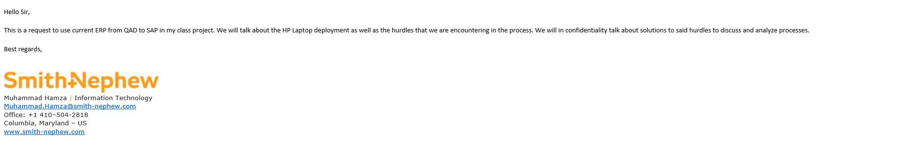

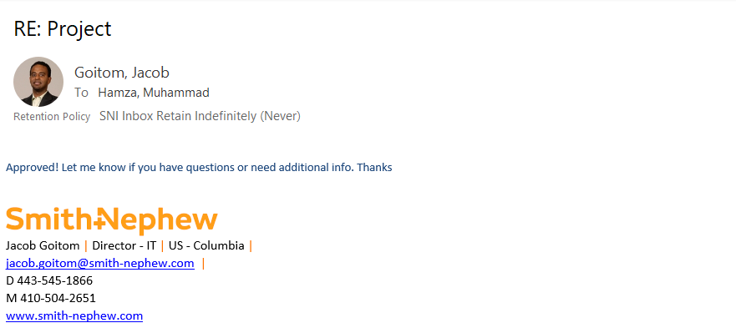

1c) Include any questionnaire you distributed, when they were distributed, response rate, etc.

List of Questions:

What is your role in the current processes and ERP handling?

How many laptops can be deployed per day to meet quota?

Is your team a responsible team to complete the task assigned?

What resources will be required to complete this project in a timely manner?

What processes can you simplify to ease the task and allow for a better workflow to exist.

Questions to be asked: Is the current ERP system efficient enough to handle new workload? What is the time-line for laptop deployments?

Who is going to Image the Machines?

Is there enough on-site support to assist with the integration?

What resources will be required to complete this project in a timely manner.

2) Perform use case analysis and produce the use case documents for your project (a use case typically covers one or more functions in the functional requirements. Note that you will be writing more than one use case. For arrows, you can simply use <= and => .

Use Case# 1 Deployment Laptops Priority: High

Use Case# 2 Conversion from QAD to SAP Priority: High

Actor: IT Department- Merger Team

Use Case# 3 Uploading Software on Devices Priority: High

Actor: Software deployment team

Description: Process of uploading software packages on end users devices

Trigger: When Laptops are all deployed

Type: Internal

Preconditions:

1. Laptops deployed to department
2. Software team has all software packages on hand
3. Time frame of when software has to be deployed on devices

Normal Course:

1. Obtain all laptops on hand
2. Software team to order all licensing agreements and packages for applications to be downloaded
3. Arrange time for deployment
4. Have teams login to laptops and import all software packages/licensing on devices
5. Have all laptops completed and ready for user to login

Alternative Course:

1. Laptop subscriptions not working
   1. Contact company
2. Time Management
3. Laptops not arrived
   1. Contact deployment team for expected date
4. Laptop issues
   1. Contact IT help desk to configure laptops
5. Laptops not ready to be delivered to end users
   1. Inform users of delay

Postconditions:

1. Software packages on all devices
2. User login and passwords created for all work users
3. Laptops and devices finished deployment

**Project Plan**

|  |  |  |  |  |  |
| --- | --- | --- | --- | --- | --- |
| TASK ID | TASK NAME | Estimated | | | |
| Assigned to: | Duration | Start date | Finish date |
| 1 | **Planning** | Hamza, Shaikha, Siril, Khadija, Josh, Jay | 4 weeks | 9/25/2019 | 10/23/2019 |
| 1.a | Gathering Requirements |  | TBD |  |  |
| 1.b | Create a project plan |  | TBD |  |  |
| 1.c | Financial planning |  | TBD |  |  |
|  |  |  |  |  |  |
| 2 | **Analysis** | Josh, Khadija, Hamza, Shaikha | 3 weeks | 10/23/2019 | 11/13/2019 |
| 2.a | Understanding Requirements |  | TBD |  |  |
| 2.b | Examining changes required |  | TBD |  |  |
| 2.c | Business Analysis | Khadija | TBD |  |  |
| 2.d | Systems Analysis | Josh | TBD |  |  |
|  |  |  |  |  |  |
| 3 | **Design** | Jay, Siril, Hamza | 3 weeks | 11/13/2019 | 12/4/2019 |
| 3.a | Possible Design Options | Jay, Siril, Hamza | TBD |  |  |
| 3.b | System Design | Siril | TBD |  |  |
| 3.c | Network Infrastructure | Jay | TBD |  |  |

**KanbanFlow**

(Uploaded on GitHub)